VCD Outputs

Full Adder with Test Bench

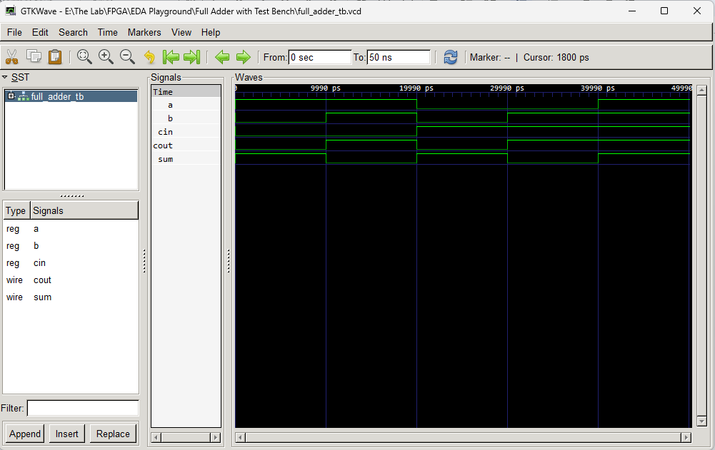

Half Adder with Test Bench

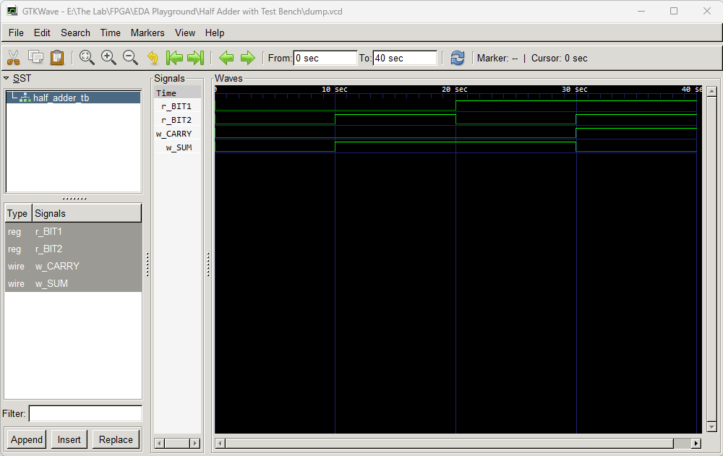

Accumulator with TB

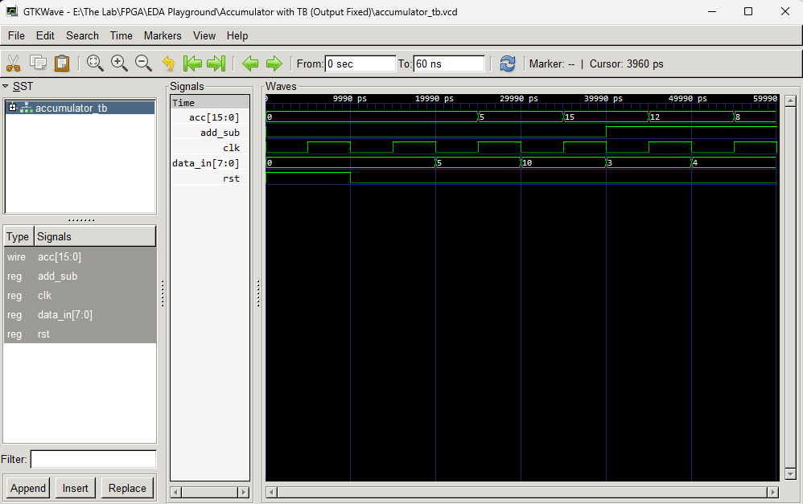

FIFO with TB

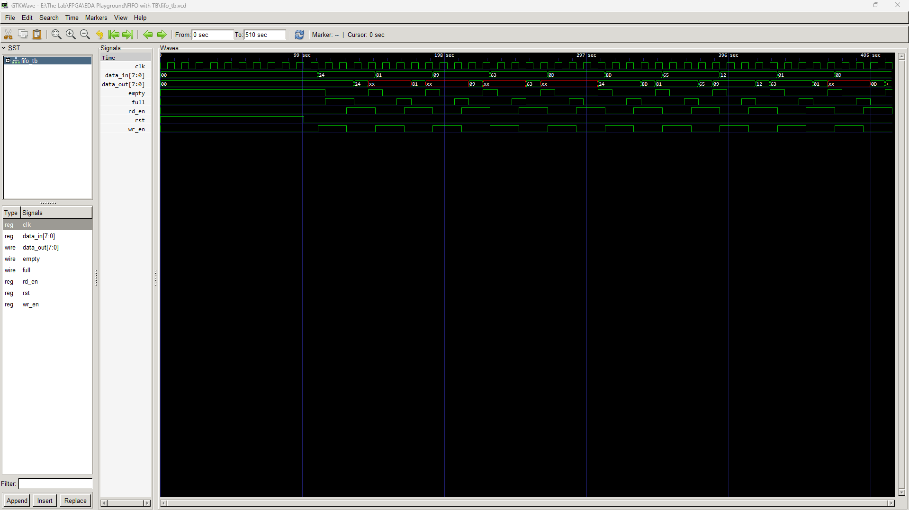

8-bit Multiplexer with TB

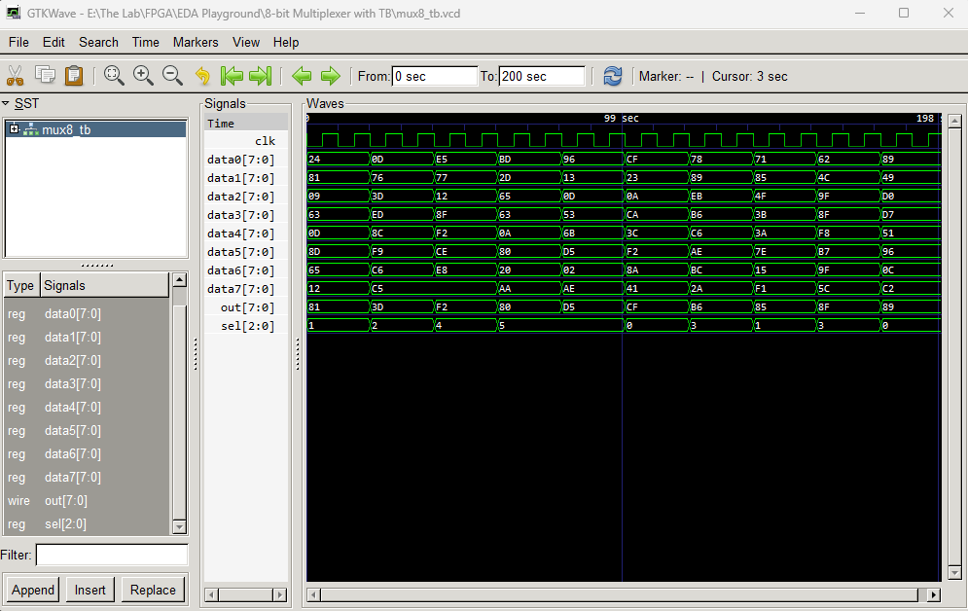

ALU with TB

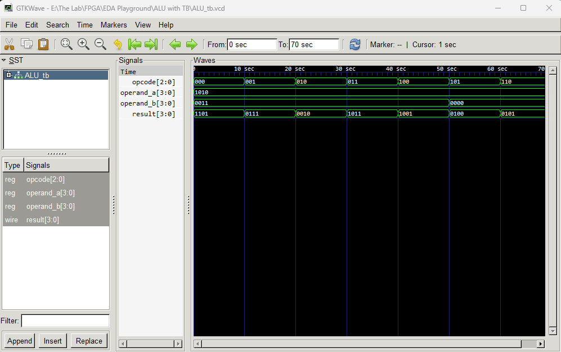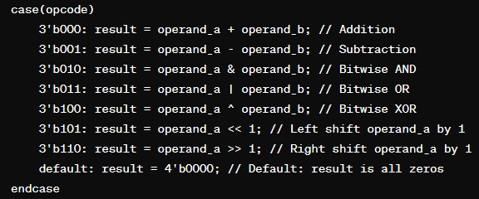

8-bit Memory with TB

* Originally not working. ChatGPT4 got it working. GPT3 could not get it working.

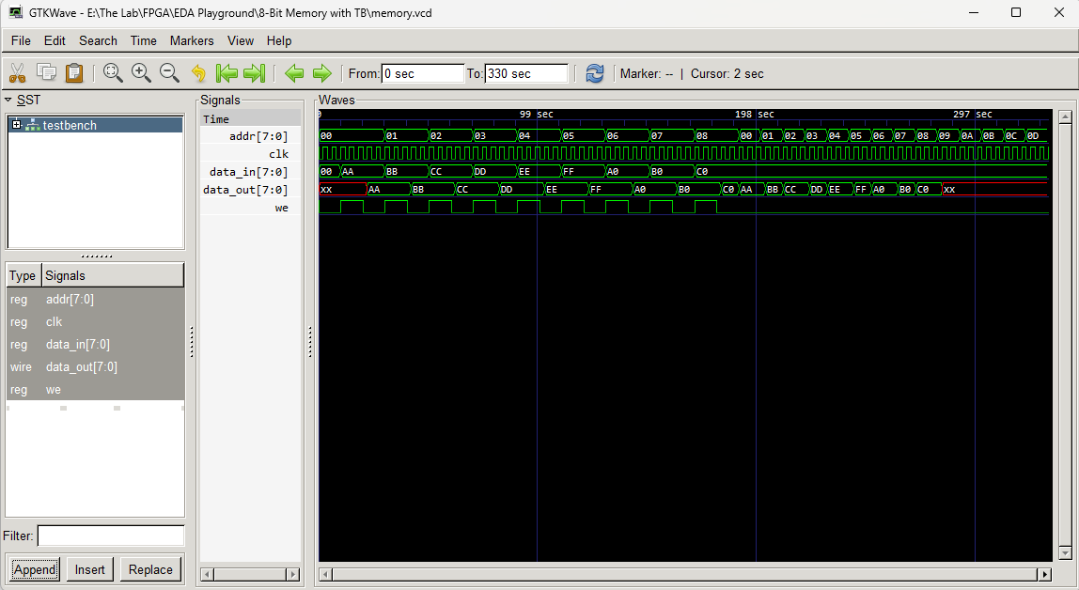

* Version 2. Testing GPT4 for repeatability.

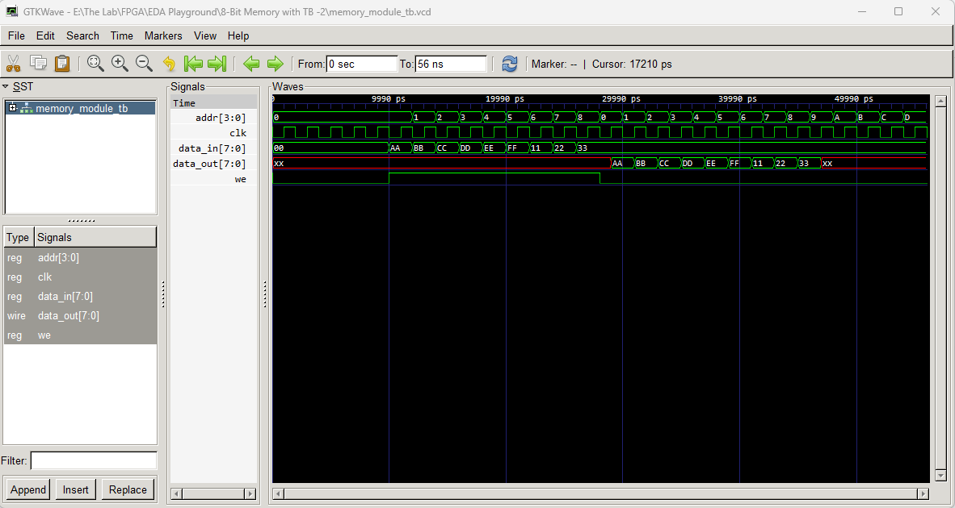

UART Transmitter/Receiver with TB

* Originally not working. ChatGPT4 got it working. GPT3 could not get it working.

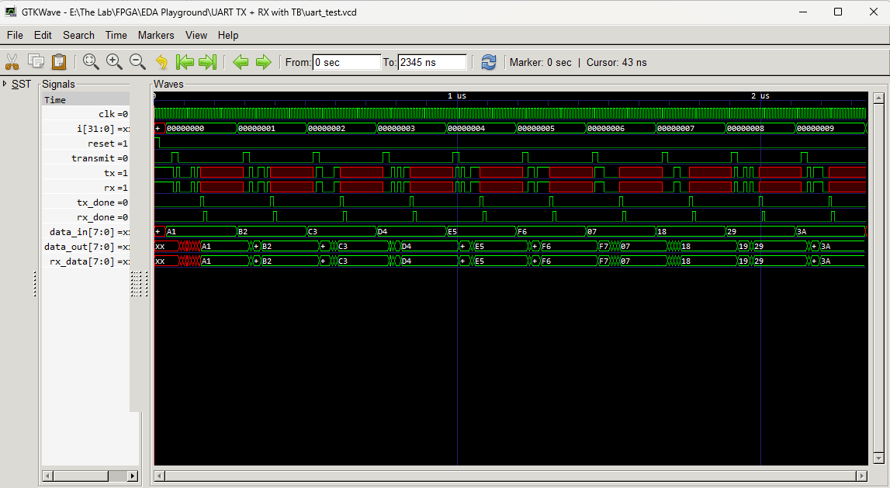

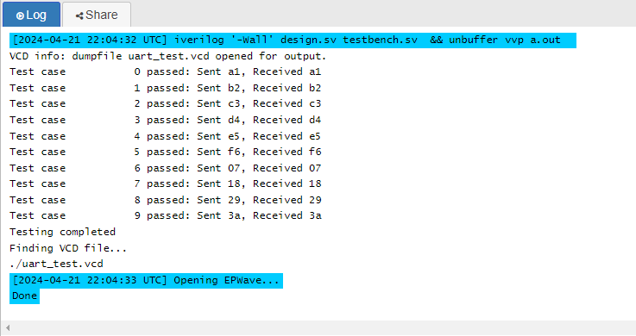

7-Segment Display Decoder

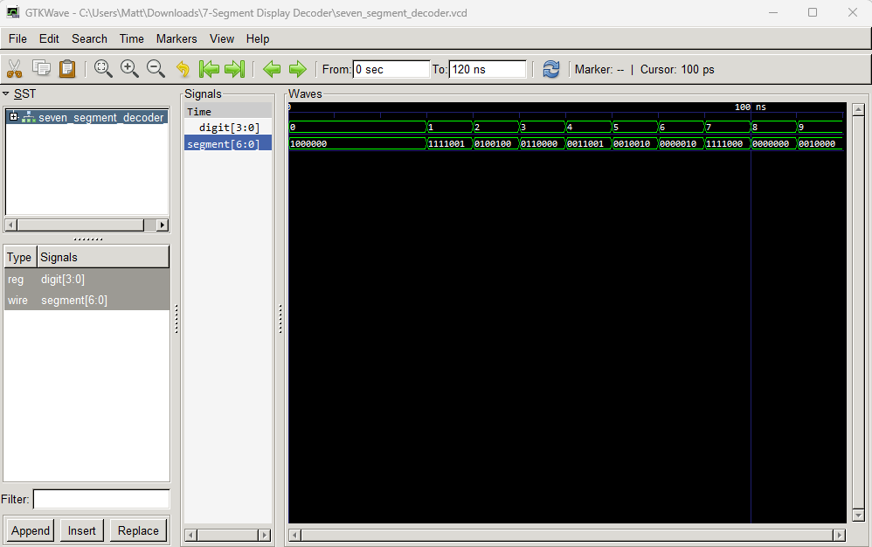

* Decoded Binary Outputs with ChatGPT

